Command to Hide the file -

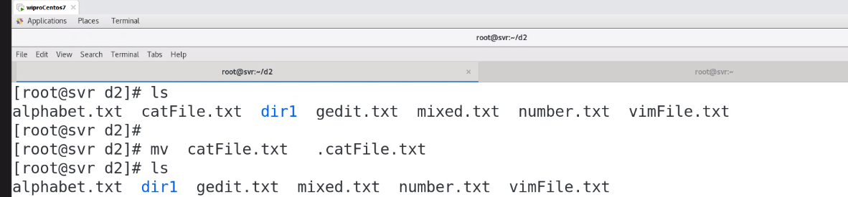

Command to Unhide the file -

